  - Name: Soniya Eknath Girhe. Sec_Batch_RollNo.: A7_B3_59.
  - Date:24/03/2026.

Practical 06

Aim
To study and implement the concept of user-defined exception handling in Java by
validating patient details using custom exception classes.

Code:
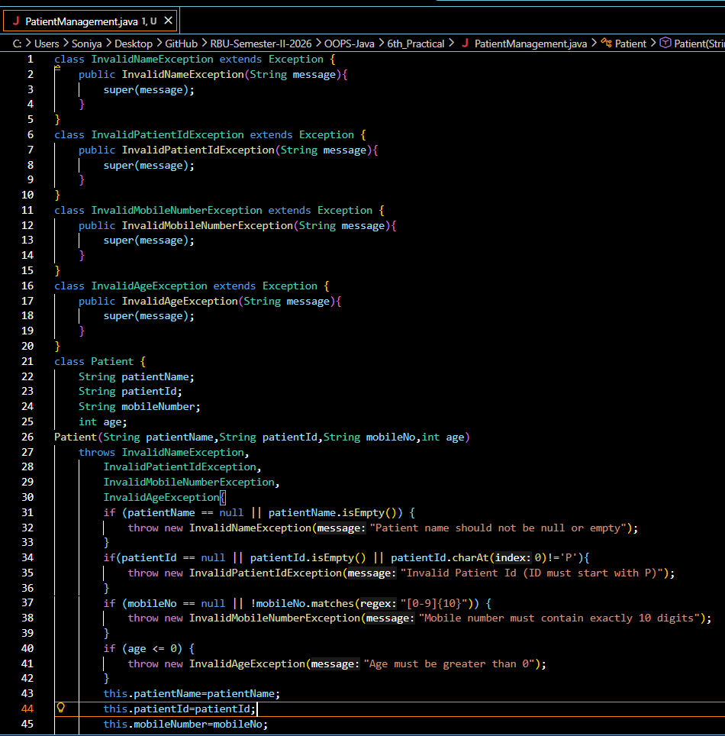
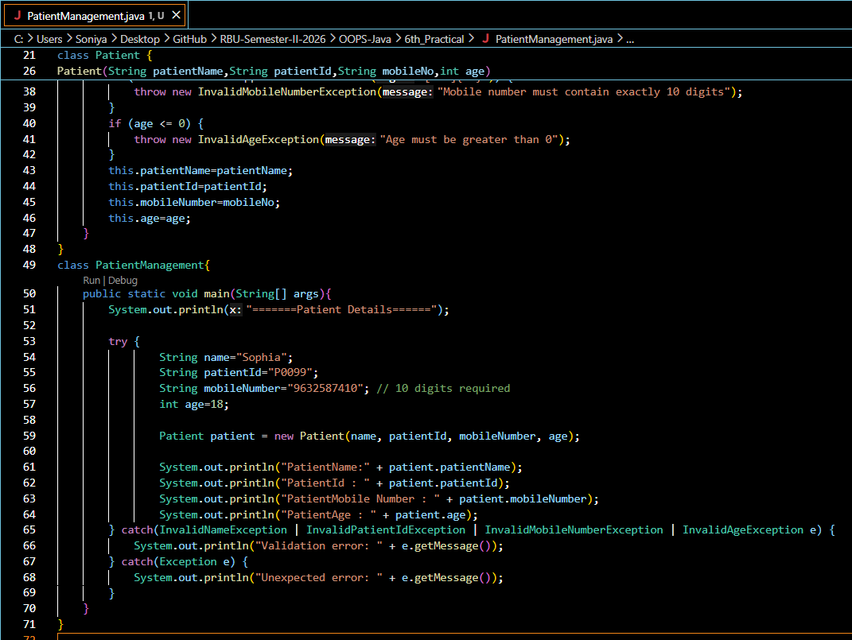

Output:
